Cairo University  
Faculty of Computers and Information



**CS251**

**Software Engineering I**

Time to Learn

Software Requirements Specifications

TenCent .1$

November 2016

Contents

Team 3

Document Purpose and Audience 3

Introduction 3

Software Purpose 3

Software Scope 3

Definitions, acronyms, and abbreviations 3

Requirements 4

Functional Requirements 4

Non Functional Requirements 4

System Models 5

Use Case Model 5

Use Case Tables 6

Ownership Report 24

GitHub link: 24

# 

# Team

|  |  |  |  |
| --- | --- | --- | --- |
| **ID** | **Name** | **Email** | **Mobile** |
| 20140049 | Adham Ayman Elmasry | Adham.a.elmasry@hotmail.com | 01066446071 |
| 20140308 | Hamsa Saber Mobarez | [hamsa.saber96@gmail.com](mailto:hamsa.saber96@gmail.com) | 01121736295 |
| 20140041 | Ahmed Mohamed Fathallah | Afathallah50@gmail.com | 01147737879 |

# Document Purpose and Audience

This document describes the requirements of the software of a game-based educational web application and the audience who will read this document are the Doctor, TAs and developers

# Introduction

## Software Purpose

The purpose from this software understands the basic educational concepts while playing simple games related to science, technology, math and programming. Also help students in their studying fields under the supervision of teachers. As well as help students not to waste their time on useless games and improve their knowledge

## Software Scope

Our software is web application it will be a game-based educational platform, the students and teachers will be able to login or to create new account to be able to see the content. The students choose the subject they want to play its games and can rate this game write comments and add his scores and progress in his achievements , Teachers can try any game they want, Create new games , they can also edit o remove any game they created and they can respond to students comments

## Definitions, acronyms, and abbreviations

|  |  |
| --- | --- |
| Category | A class or division of things have particular shared characteristics. |
| Create | Make something never exist exists. |
| platform | Is basic hardware and software on which application runs. |
| rate | Assign value to the application according to a particular scale. |

# Requirements

## Functional Requirements

* Students and Teachers should have their own accounts and features.
* Students should choose subject category and according to it the system displays the games
* Students can choose any games he want from available games
* Students Start game
* Students can start tutorial if they want to know how to play this game and they can skip this tutorial too.
* Students can play games already on system or might be created by teacher .
* After Students finish game they should see their score.
* Every Student achievements are added to his profile.
* Students should rate any game they played
* Students should write comments
* Teacher can try the games.
* Teacher should create games
* Teacher can remove any game he created
* Teacher can edit any game created by him
* Teacher shall respond to comments

## Non Functional Requirements

|  |  |
| --- | --- |
| Security | System must protect the user data and don’t allow anyone else to enter his account only the authorized person who know the account password to login |
| Usability | System must have a graphical user interface which is clear and so easy to understand how to use the application. |
| Quality | System must have backup for the entire database |
| Scalability | System should be flexible and ready to any changes and support all the needed functions |
| Performance | The software performance should be excellent ,respond quickly as much as possible in normal and heavy traffics . |

# 

# System Models

## Use Case Model

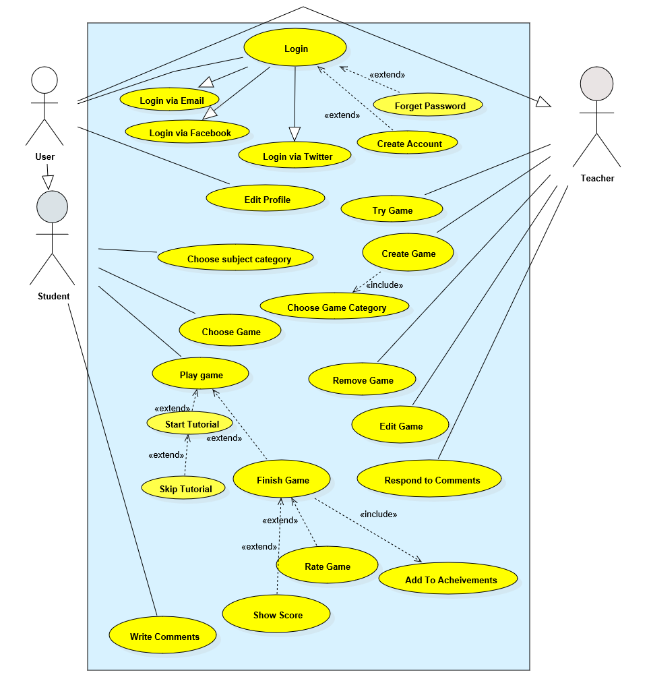

## Use Case Tables

|  |  |  |
| --- | --- | --- |
| Use Case ID: | 2 | |
| Use Case Name: | Forget Password | |
| Actors: | Teacher and Student | |
| Pre-conditions: | Student or teacher can’t remember their password | |
| Flow of events: | **User Action** | **System Action** |
| 1. Choose forget password |  |
|  | 1. System ask the user to choose if he want to send the verification code to the email or mobile |
| 1. Choose where to send verification code |  |
|  | 1. System send the verification code to the mobile number or email |
| 1. Enter the verification code |  |
|  |  | 1. System verify the code |
|  | 1. Enter new password |  |
| Exceptions: | **User Action** | **System Action** |
| 1. User enter the verification code |  |
|  | 1. the code entered is wrong 2. System ask him to enter the code again |

|  |  |  |
| --- | --- | --- |
| Use Case id: | 3 | |
| Use Case Name: | Create Account | |
| Actors: | Teacher and Student | |
| Pre-conditions: | Student or Teacher don’t have an account | |
| Flow of events: | **User Action** | **System Action** |
| 1. Choose create account |  |
|  | 1. Displays the form he has to fill |
| 1. Fill all the fields |  |
|  | 1. verify that all the information he entered is correct |
|  | 1. add his account to System |
| Exceptions: | **User Action** | **System Action** |
| 1. user fill the required fields |  |
|  | 1. System verify his information and found something wrong 2. System ask him to enter it again |
| Notes & Issues | Anyone to can see the content of the application must has an account | |

|  |  |  |
| --- | --- | --- |
| Use Case ID: | 4 | |
| Use Case Name: | Edit Profile | |
| Actors: | Teacher and Student | |
| Pre-conditions: | Student or Teacher Login | |
| Flow of events: | **User Action** | **System Action** |
| 1. Choose edit profile |  |
|  | 1. Display the contents he can edit. |
| 1. Edit fields and choose save |  |
|  | 1. Verify the entered data 2. System update data |
| Exceptions: | **User Action** | **System Action** |
| 1. Edit fields and choose save |  |
|  | 1. Verify the new entered data 2. The data entered is wrong 3. Ask the user to enter the data again. |
| Notes & Issues | If the user want to update his personal information or change password or email. | |

|  |  |  |
| --- | --- | --- |
| Use Case ID: | 5 | |
| Use Case Name: | Choose subject category | |
| Actors: | Student | |
| Pre-conditions: | Student login | |
| Post-conditions: | Display the games related to this subject | |
| Flow of events: | **User Action** | **System Action** |
| 1. Student choose choose subject category |  |
|  | 1. System display the available subjects |
| 1. Student choose the subject |  |
| Notes & Issues |  | |

|  |  |  |
| --- | --- | --- |
| Use Case ID: | 6 | |
| Use Case Name: | Choose game | |
| Actors: | Student | |
| Pre-conditions: | Student Choose subject category | |
| Flow of events: | **User Action** | **System Action** |
| 1. student choose subject |  |
|  | 1. system displays the available games for this subject. |
| 1. Student choose game |  |
|  | 1. System view game |

|  |  |  |
| --- | --- | --- |
| Use Case ID: | 7 | |
| Use Case Name: | Start game | |
| Actors: | Student | |
| Pre-conditions: | Student choose game | |
| Flow of events: | **User Action** | **System Action** |
| 1. Student Choose game |  |
|  | 1. System ask if he want to start game |
| 1. Student choose start game |  |
|  | 1. System starts the game |

|  |  |  |
| --- | --- | --- |
| Use Case ID: | 8 | |
| Use Case Name: | Start tutorial | |
| Actors: | Student | |
| Pre-conditions: | Student Start game | |
| Flow of events: | **User Action** | **System Action** |
| 1. Student choose game |  |
| 1. Student start game |  |
|  | 1. System display options play game and Start tutorial |
| 1. Student choose Start tutorial |  |
|  | 1. System plays tutorial video |
| Include: | Extend from use case 7 | |
| Notes & Issues | Tutorial shows the student how to play this game if he don’t know | |

|  |  |  |
| --- | --- | --- |
| Use Case ID: | 9 | |
| Use Case Name: | Skip tutorial | |
| Actors: | Student | |
| Pre-conditions: | Student choose start tutorial | |
| Post-conditions: |  | |
| Flow of events: | **User Action** | **System Action** |
| 1. Student start game |  |
| 1. Student Start tutorial |  |
|  | 1. System display tutorial video 2. System show skip tutorial |
| 1. Student choose skip tutorial |  |
|  | 1. System ends video and play the game |
| Exceptions: | **User Action** | **System Action** |
| 1- student choose skip tutorial |  |
|  | 2- System found that 5 seconds didn’t pass yet  3-System refuse to skip |
| Include: | Extend from use case 8 | |
| Notes & Issues | When the Student don’t want to continue the tutorial video he can choose skip video after passing 5 seconds from playing it , and directly start playing the game | |

|  |  |  |
| --- | --- | --- |
| Use Case ID: | 10 | |
| Use Case Name: | Play game | |
| Actors: | Student | |
| Pre-conditions: | Student Start game | |
| Flow of events: | **User Action** | **System Action** |
| 1. Student Start game |  |
|  | 1. System displays game 2. System displays two options Start tutorial and play |
| 1. Student choose play game |  |
|  | 1. System record the score and progress |
| Include: | Extend from use case 7 | |
| Notes & Issues | Student play the game and move from level to another and he can stop the game whenever he want and when play it again continue from where he stopped and he can repeat any level he wants to improve his score in this level | |

|  |  |  |
| --- | --- | --- |
| Use Case ID: | 11 | |
| Use Case Name: | Finish game | |
| Actors: | Student | |
| Pre-conditions: | Student Play game | |
| Flow of events: | **User Action** | **System Action** |
| 1. Student Start game |  |
| 1. Student play game |  |
|  | 1. System display the game |
| 1. Student choose finish game |  |
|  | 1. System stop the game |
| Include: | Extend from use case 10 | |
| Notes & Issues | Student want to stop the game choose finish game and the System show his score | |

|  |  |  |
| --- | --- | --- |
| Use Case ID: | 12 | |
| Use Case Name: | Show score | |
| Actors: | Student | |
| Pre-conditions: | Student finish game | |
| Flow of events: | **User Action** | **System Action** |
| 1. Student play game |  |
| 1. Student finish game |  |
|  | 1. System stop game |
| 1. Student choose show score |  |
|  | 1. System display his score |
| Exceptions: | **User Action** | **System Action** |
| 1. Student choose show score before finishing |  |
|  | 1. System don’t take any action |
| Include: | Extend from use case 11 | |

|  |  |  |
| --- | --- | --- |
| Use Case ID: | 13 | |
| Use Case Name: | Rate game | |
| Actors: | Student | |
| Pre-conditions: | Student finish game | |
| Flow of events: | **User Action** | **System Action** |
| 1. Student play game |  |
| 1. Student finish game |  |
|  | 1. System allow rate game option |
| 1. Student rate game |  |
|  | 1. System save his rate |
| Exceptions: | **User Action** | **System Action** |
| 1. Student rate game without playing it |  |
|  | 2-System refuse to accept his rate |
| Include: | Extend from use case 11 | |
| Notes & Issues | Allow student to rate the game to know how much it was useful and good and know if it needs any changes | |

|  |  |  |
| --- | --- | --- |
| Use Case ID: | 14 | |
| Use Case Name: | Add to achievements | |
| Actors: | Student | |
| Pre-conditions: | Student finish game | |
| Flow of events: | **User Action** | **System Action** |
| 1. Student play game |  |
| 1. Student finish game |  |
|  | 1. System add his score to his achievements |
| Include: | Included in use case 11 | |
| Notes & Issues | Every time Student play game its score added to his achievements in profile | |

|  |  |  |
| --- | --- | --- |
| Use Case ID: | 15 | |
| Use Case Name: | Write Comments | |
| Actors: | Student | |
| Pre-conditions: | Student play game | |
| Flow of events: | **User Action** | **System Action** |
| 1. Student play game |  |
| 1. Student write Comment |  |
|  | 1. System save his comment and allow reply to it from teacher or other Students |
| Exceptions: | **User Action** | **System Action** |
| 1. Student Comment on game without playing it |  |
|  | 1. System refuse to add hie comment |
| Notes & Issues | Allow student to ask teachers or another students about things they want to know | |

|  |  |  |
| --- | --- | --- |
| Use Case ID: | 16 | |
| Use Case Name: | Try game | |
| Actors: | Teacher | |
| Pre-conditions: | Teacher login | |
| Flow of events: | **User Action** | **System Action** |
| 1. Teacher login |  |
| 1. Teacher choose try game |  |
|  | 1. System displays all available games |
| 1. Teacher choose one and start playing |  |
| Notes & Issues | Allow the teacher to try any game he wants to try even any game he made | |

|  |  |  |
| --- | --- | --- |
| Use Case ID: | 17 | |
| Use Case Name: | Create game | |
| Actors: | Teacher | |
| Pre-conditions: | Teacher login | |
| Flow of events: | **User Action** | **System Action** |
| 1. Teacher login |  |
|  | 1. System view create game option and other options |
| 1. Teacher choose create game |  |
| Notes & Issues | Allow Teacher to create his game and add it to games and Student can go and play it , Rate it and write comments on it too | |

|  |  |  |
| --- | --- | --- |
| Use Case ID: | 18 | |
| Use Case Name: | Choose game category | |
| Actors: | Teacher | |
| Pre-conditions: | Teacher choose create game | |
| Flow of events: | **User Action** | **System Action** |
| 1. Teacher choose create game |  |
|  | 1. System view Content of Create game 2. Ask him to choose game category |
| 1. Teacher choose category |  |
|  | 1. System view the content needed to create game from this category |
| 1. Teacher start to create his own game |  |
| Include: | Included in use case 17 | |

|  |  |  |
| --- | --- | --- |
| Use Case ID: | 19 | |
| Use Case Name: | Remove game | |
| Actors: | Teacher | |
| Pre-conditions: | Teacher login | |
| Flow of events: | **User Action** | **System Action** |
| 1. Teacher login |  |
|  | 1. System view Remove game option and other options |
| 1. Teacher choose Remove game |  |
|  | 1. System view games |
| 1. Teacher choose game he wants to remove |  |
|  |  | 1. System remove game |
| Exceptions: | **User Action** | **System Action** |
| 1. Teacher choose game he didn’t create |  |
|  | 1. System refuse to remove it |
| Notes & Issues | Allow Teacher to remove any game he doesn’t want it any more to be in the system only if is created by him | |

|  |  |  |
| --- | --- | --- |
| Use Case ID: | 20 | |
| Use Case Name: | Edit game | |
| Actors: | Teacher | |
| Pre-conditions: | Teacher login | |
| Flow of events: | **User Action** | **System Action** |
| 1. Teacher login |  |
|  | 1. System view edit game option and other options |
| 1. Teacher choose edit game |  |
|  | 1. System displays games |
| 1. Teacher choose the game wants to edit |  |
|  | 1. Teacher start editing |  |
|  |  | 1. System save changes |
| Exceptions: | **User Action** | **System Action** |
| 1. Teacher choose game he didn’t create |  |
|  | 1. System refuse editing |
| Notes & Issues | Allow teacher to edit his game add new features or levels or change colors anything he want to do | |

|  |  |  |
| --- | --- | --- |
| Use Case ID: | 21 | |
| Use Case Name: | Respond to comments | |
| Actors: | Teacher | |
| Pre-conditions: | Teacher login | |
| Flow of events: | **User Action** | **System Action** |
| 1. Teacher login |  |
|  | 1. System announce him that there are comments written for games he created |
| 1. Teacher open comments |  |
|  | 1. System view comments |
| 1. Teacher start responding |  |
|  |  | 1. System save his responds |

# Ownership Report

**.**

|  |  |
| --- | --- |
| **Item** | **Owners** |
| Software Purpose | Adham, Hamsa, Ahmed |
| Software Scope | *Ahmed , Hamsa , Adham* |
| Functional and non-Functional Requirements | *Hamsa* |
| Use Case model | *Hamsa, Adham, Ahmed* |
| Use case tables | *Adham, Hamsa, Ahmed* |

# GitHub link:

# https://github.com/HamsaMobarez/SoftWare_Project